Instroduction to Lighting

Lighting is one of the most crucial elements in interior design, playing a significant role in how spaces are experienced and perceived. It is not only essential for visibility and function but also for creating mood, enhancing aesthetics, and influencing the overall ambiance of a space. A well- lit room feels more inviting, spacious, and harmonious. Conversely, poor lighting can make a space feel uncomfortable, cold, or disjointed. Understanding how to design lighting effectively is a fundamental skill for every interior designer.

# Understanding the Role of Lighting in Interior Design

Before delving into types and techniques, it is important to grasp why lighting holds such a central place in design. Lighting can shape a room by altering how colors and textures are perceived, creating illusions of space, and helping to define functionality in different zones of a room. It brings interiors to life, supports the wellbeing of the occupants, and reinforces the style and purpose of a space.

**Visibility and Functionality:** Lighting ensures that people can move safely through spaces and perform tasks efficiently.

**Mood and Atmosphere**: Lighting intensity, colour, and direction can dramatically affect the mood of a room. Soft, warm light can create a cozy atmosphere, while bright, cool light can make a space feel energetic.

**Aesthetic Enhancement**: Lighting can be used to highlight architectural features, artwork, or textured surfaces, enhancing the visual appeal of a space.

**Spatial Perception:** Proper lighting can make small rooms feel larger and low ceilings feel higher. It can help to balance proportions and guide the eye.

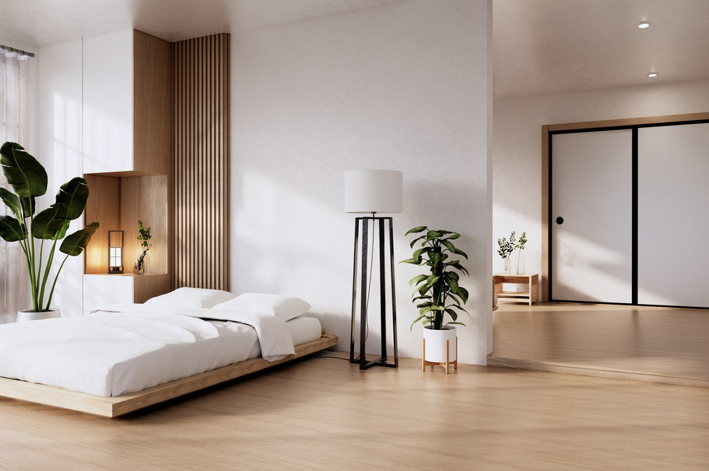

Fig 1. Navamin Studio (nd), [Room with lighting](https://www.canva.com/photos/MAEqYQtebIU/)

# Types of Lighting

Lighting can be classified into several types based on its function in a space. Each type serves a specific purpose, and effective lighting design often involves layering these types to create a balanced and flexible environment.

**General (Ambient) Lighting:** This is the base level of lighting that provides overall illumination. It ensures that a room is lit evenly, and is typically achieved through ceiling-mounted fixtures such as chandeliers, flush mounts, or recessed lighting. General lighting sets the tone of the room and supports basic visibility.

**Task Lighting:** This is focused lighting intended to illuminate specific areas where precision is required, such as reading, cooking, or working. Examples include desk lamps, pendant lights over counters, and under-cabinet lights. It should be bright enough to reduce eye strain but controlled to avoid glare.

**Accent Lighting/ Mood Lighting:** Accent or Mood lighting is used to either draw attention to focal points like artwork, plants, or architectural details. Or it can act as subtle lighting layers that add softness and atmosphere without overwhelming the space. It creates visual interest and adds depth to a space. Wall-mounted picture lights, spotlights, and directional recessed lighting are common accent lighting options, whilst mood lighting may include wall sconces, LED strips, or soft-glow lamps that create a relaxing ambiance ideal for living rooms and bedrooms.

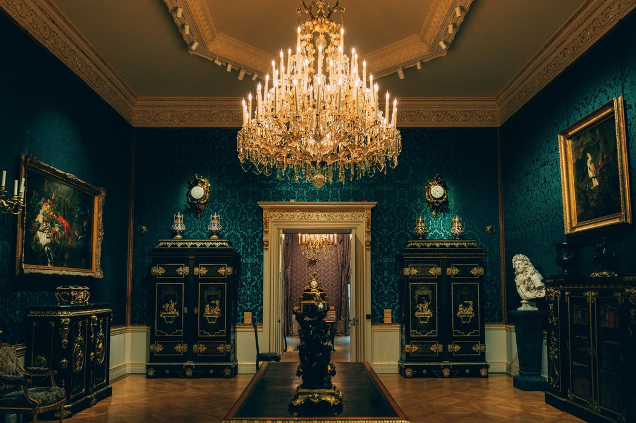

Fig 2. Pexels (nd), [Chandelier in Room](https://www.canva.com/photos/MAGZHicJkuQ/)

# Lighting Options and Fixtures

Fixtures come in a wide range of styles and functions. Choosing the right fixture depends on the lighting purpose, the scale of the space, and the desired aesthetic. Each type offers unique benefits and challenges.

**Recessed Lighting:** Installed into the ceiling, these fixtures provide a clean, modern look. They are ideal for ambient or accent lighting and work well in spaces with lower ceilings. **Pendant Lights:** Hanging fixtures that can provide both task and decorative lighting. They are commonly used over kitchen islands, dining tables, or entryways to draw the eye downward and create intimacy.

**Wall Sconces:** These are mounted on walls and can serve as both functional and decorative lighting. They are great for hallways, bathrooms, or adding layers of light in larger rooms.

**Track Lighting:** These systems feature multiple adjustable heads on a single track, allowing for flexibility in directing light. Ideal for highlighting art or retail displays.

**Floor and Table Lamps:** Versatile and movable, these provide task or ambient lighting and can be used to complement other fixtures while adding personality to a space.

**LED Strip Lighting:** Thin, flexible strips often used in under-cabinet lighting, cove lighting, or behind furniture for a subtle glow. They are energy-efficient and easy to install.

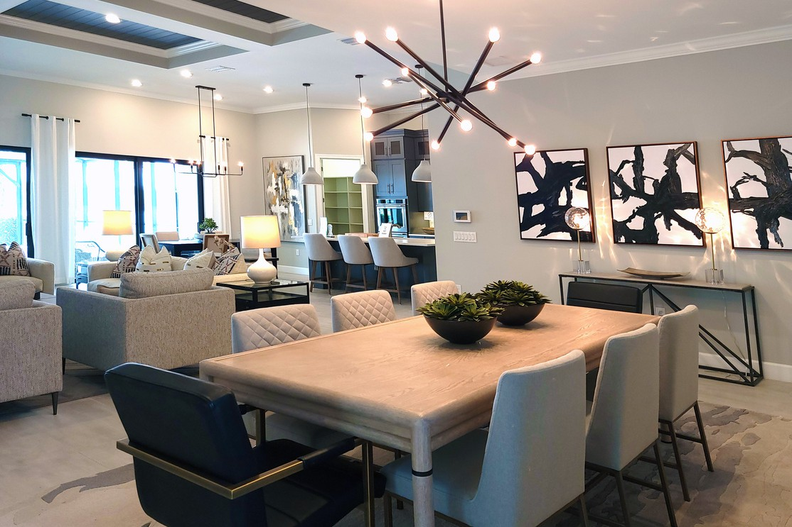

Fig 3. Pexels (nd), [Interior Design of a House](https://www.canva.com/photos/MAEczGplvm8/)

# Characteristics of Light

Understanding the technical aspects of light is vital to making informed decisions about lighting in a space. These characteristics influence not only the function of lighting but also how it interacts with surfaces and colours.

**Intensity (Brightness):** Measured in lumens, brightness refers to how much light a bulb emits. Rooms with specific tasks, such as kitchens or studies, require more intense lighting than a lounge or bedroom.

**Colour Temperature:** Measured in Kelvin (K), this describes the warmth or coolness of light. Lower Kelvin values (2700K-3000K) produce warm light that feels cozy and inviting. Higher values (5000K-6500K) emit cooler, bluish light that enhances concentration and alertness.

Choosing the right colour temperature can reinforce the intended mood of the room.

**Direction:** The angle at which light is cast affects how shadows fall and how objects are perceived. Uplighting can make a ceiling seem higher, while downlighting can focus attention or create intimacy.

**CRI (Colour Rendering Index):** CRI measures how accurately a light source reveals the true colours of objects. A CRI of 80 or above is recommended for residential interiors to maintain colour fidelity.

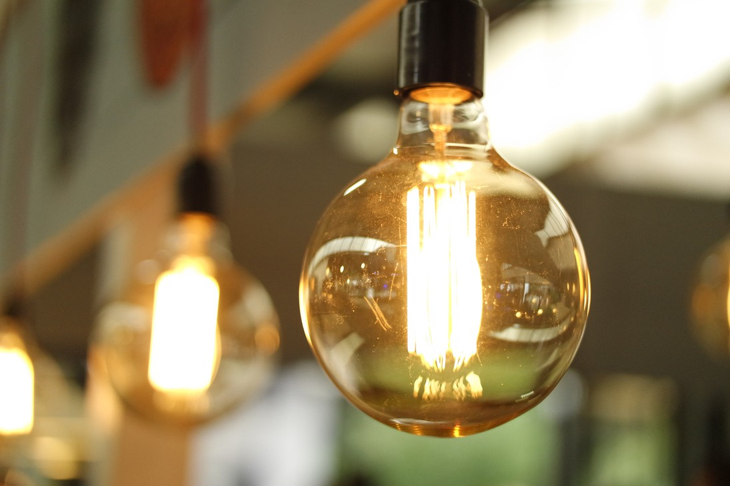

Fig 4. Pexels (nd), [Lighted Light bulb](https://www.canva.com/photos/MADGx3-cQVg/)

# Calculating the amount of Light needed

Determining the appropriate amount of light ensures that a room is neither too dim nor excessively bright. Although this calculation can be helpful in order to achieve comfort and functionality, it is important to remember that lighting options must be approached holistically with the client and the particular space in mind.

To estimate the required light, use the following formula:

**Room area in square metres × recommended lumens per square metre (lux) = total lumens needed**

Living Room: 100–200 lux – provides a warm, inviting atmosphere suitable for relaxation. Kitchen: 300–400 lux – ensures bright, clear lighting for cooking and food preparation.

Bedroom: 100–200 lux – offers soft lighting ideal for rest and relaxation.

Bathroom: 700–800 lux – supports grooming and personal care with bright, focused lighting. Workspace/Office: 500–800 lux – promotes concentration and reduces eye fatigue.

**Example**: For a 14 m² kitchen: 14 × 300 lux = 4,200 lumens minimum.

This method ensures that lighting levels meet the functional needs of the space while enhancing comfort and usability.

# Hints and Tips for Great Lighting Design

Applying lighting well involves more than choosing beautiful fixtures. It requires thoughtful placement, layering, and adaptation to the space's needs and the activities performed there.

1. **Plan Early:** Integrate lighting into the initial design stages to ensure wiring and fixture placement complement the layout.
2. **Natural Light Matters:** Maximise daylight and design artificial lighting to complement and extend natural brightness.
3. **Think Vertically:** Distribute lighting across different heights—floor lamps, sconces, ceiling lights—to create a sense of dimension.
4. **Mix Materials:** Materials like glass, metal, and fabric affect light diffusion. Use them to shape how light is dispersed and perceived.
5. **Use Smart Controls**: Incorporate smart lighting systems for convenience, energy savings, and mood customisation.
6. **Avoid Over-lighting**: Too much light can make a space feel sterile. Focus on creating balance and subtle contrasts.

Lighting is a dynamic and transformative element of interior design. By understanding the types, characteristics, and applications of light, designers can create interiors that are not only beautiful but also functional and emotionally resonant. Whether enhancing a cozy reading nook or planning a professional kitchen, thoughtful lighting design is the key to elevating a space from ordinary to extraordinary.